A
PROJECT REPORT
ON
“UNI TECH SPACE”
BACHELOR OF TECHNOLOGY
IN
COMPUTER SCIENCE AND ENGINEERING (CYBERSECURITY)
BY
P.KAVYA JAYASREE - 24N81A6231
L.NIKHITHA - 24N81A6228
M.PALLAVI- 24N81A6229
Under the Guidance of
Mrs. A. Sandhya Rani
Assistant Professor
Department of CSE (CYBERSECURITY)


DEPARTMENT OF COMPUTER SCIENCE AND ENGINEERING (CS) SPHOORTHY ENGINEERING COLLEGE
Nadergul (Vill.), Near L.B. Nagar, Hyderabad, Telangana – 501510.
[2024-2028]

FACULTY INCHARGE HEAD OF DEPARTMENT
SPHOORTHY ENGINEERING COLLEGE
DEPARTMENT OF COMPUTER SCIENCE AND ENGINEERING (CS)

CERTIFICATE
This is to certify that this Project Based Learning Report entitled Secure OS Access Control System is a Bonafide work carried out by P. Kavya Jayasree 24N81A6231, L. Nikhitha 24N81A6228, M. Pallavi 24N81A6229,in partial fulfilment of the requirements for the award of degree of Bachelor of Technology in Computer Science and Engineering (CYBERSECURITY) from Sphoorthy Engineering College, affiliated to Jawaharlal Nehru Technological University Hyderabad, during the Academic Year 2025-26 under our guidance and supervision.
The results embodied in this report have not been submitted to any other university or institute for the award of any degree or diploma.

Internal Guide Head of the Department
Mrs. A. Sandhya Rani
Assistant Professor
Department of CSE (CYBERSECURITY) SPHN

DECLARATION
We the undersigned, declare that the Project Based Learning title “UNI TECH SPACE” carried out at “SPHOORTHY ENGINEERING COLLEGE” is original and is being submitted to the Department of COMPUTER SCIENCE AND ENGINEERING (CS), Sphoorthy Engineering College, Hyderabad towards partial fulfilment for the award of degree of Bachelor of Technology.
We declare that the result embodied in the Project Based Learning using Nodejs ,CN, OS has not been submitted to any other University or Institute for the award of any Degree or Diploma.
Date:
Place:
GROUP MEMBERS:
P.KAVYA JAYASREE - 24N81A6231
L.NIKHITHA - 24N81A6228
M.PALLAVI- 24N81A6229

ACKNOWLEDGEMENT
We sincerely thank our Project Guide Mrs. A. Sandhya Rani, Asst. Professor, Department of Computer Science & Engineering (CS), Sphoorthy Engineering College, for her inspiring guidance, consistent encouragement, constructive criticism and helpful suggestions during the entire course of my project work.
We express our sincere thanks to Dr. Ramarao KVSN, Professor & Head of the Department, Department of Computer Science & Engineering (CS), Sphoorthy Engineering College, Nadergul (V), Balapur (M), Ranga Reddy (D) for their encouragement which helped us to complete the Project work.
We deem it a great privilege to express our profound gratitude and sincere thanks to Mr. S. Chalama Reddy, Chairman, Mr. S. Jagan Mohan Reddy, Secretary, Dr. K. Srinivas Rao, Principal, Sphoorthy Engineering College, Nadergul (V), Balapur (M), Ranga Reddy (D), for their moral support and help in the completion of the project work.
We express our heartfelt thanks to Professors, Associate Professors, Assistant Professor and other professional non-teaching staff of Department of Computer Science and Engineering (CS), Sphoorthy Engineering College, Nadergul (V), Balapur (M), Ranga Reddy (D) for providing the necessary information pertaining to our project work.
BATCH: 2024 – 2028
GROUP MEMBERS:
P.KAVYA JAYASREE - 24N81A6231
L.NIKHITHA - 24N81A6228
M.PALLAVI- 24N81A6229

ABSTRACT
UNI TECH SPACE is a web-based platform developed to guide students in choosing suitable career domains in Computer Science and related technologies. The platform provides multiple functionalities such as domain exploration, rank prediction, educational resources, quiz-based domain prediction, YouTube learning resources, and file uploading features.
The system allows users to register and log in securely to access personalized features. Students can explore different technical domains like Web Development, Artificial Intelligence, Cyber Security, Data Science, Cloud Computing, and more. A quiz module analyzes user interests and skills to predict the most suitable domain for their career path.
Additionally, the platform includes a Rank Predictor system that helps students estimate their admission possibilities based on ranks. Users can also access learning materials, watch YouTube tutorials, and upload important files/resources for future reference.
The project is developed using modern web technologies with an interactive and user-friendly interface. The main objective of the system is to provide students with a centralized career guidance and learning platform.
GROUP MEMBERS:
P.KAVYA JAYASREE - 24N81A6231
L.NIKHITHA - 24N81A6228
M.PALLAVI- 24N81A6229

I
INDEX
II
Contents |  |  | Page No.
Abstract |  |  | I
Index |  |  | II
List of Figures |  |  | III
CHAPTERS
1. | Introduction |  | 1
 | 1.1 | Problem Statement | 1
 | 1.2. | Objective | 1
 | 1.3. | Existing System | 1
 | 1.4. | Proposed System | 2
 | 1.5. | Scope | 2
 | 1.6. | Software & Hardware Requirements | 3
2. | Literature Survey |  | 4
 | 2.1. | Survey of Major Area Relevant to Project | 4
 | 2.2. | Techniques and Algorithms | 4
 | 2.3. | Applications | 5
3. | System Design |  | 6
 | 3.1. | System Architecture | 6
 | 3.2. | System Flow | 7
 | 3.3. | Module Description | 8
 | 3.4. | UML Diagram | 9
4. | Implementation |  | 13
 | 4.1. | Environmental Setup | 13
 |  | 4.1.1 Development Environment | 13
 | 4.2. | Implementation of Modules | 13
 | 4.3. | Integration and Development | 15
5. | Evaluation |  | 16
 | 5.1. | Modules | 16
 | 5.2. | Evaluation Metrics | 17
 | 5.3. | Test Cases | 17
 | 5.4 | Results | 23
6. | Conclusion and Future Enhancement |  | 24
 | References |  | 26
 | Appendix and Sample code |  | 27

LIST OF FIGURES
Figure No. | Figure Name | Page No.
3.2.1 | Use Case Diagram | 9
3.2.2 | Class Diagram | 10
3.2.3 | Sequence Diagram | 11
3.2.4 | Activity Diagram | 12
5.3.1 | Successful Registration | 17
5.3.2 | Duplicate Registration | 18
5.3.3 | Successful Login+OTP Output | 18
5.3.4 | Invalid Login Output | 18
5.3.5 | Account Lock Output | 19
5.3.6 | Wrong OTP Output | 19
5.3.7 | View Profile Output | 19
5.3.8 | Change Password Output | 20
5.3.9 | Access Resources Output | 20
5.3.10 | Quiz Function Output | 20
5.3.11 | Admin- View Users Output | 21
5.3.12 | Admin- Delete Users Output | 21
5.3.13 | Admin- View Logs Output | 22
5.3.14 | Logout Output | 22

III

CHAPTER-1
INTRODUCTION
  - PROBLEM STATEMENT
Many students face confusion while selecting suitable technical domains and career paths due to lack of proper guidance and centralized learning resources. Existing platforms provide either learning materials or career guidance separately, which makes it difficult for students to make informed decisions.
There is a need for a system that:
- Helps students explore domains
- Predicts suitable domains based on interests
- Provides educational resources
- Allows rank prediction
- Offers secure user authentication
  - OBJECTIVE
The objectives of UNI TECH SPACE are:
- To provide domain guidance for students
- To predict suitable technical domains using quizzes
- To offer learning resources and YouTube tutorials
- To provide rank prediction functionality
- To allow authenticated access to users
- To create a centralized educational platform
  - EXISTING SYSTEM
Existing systems generally focus on only one functionality such as:
- Online learning platforms
- Career counseling websites
- Rank prediction systems
Limitations:
- No personalized domain prediction
- Lack of integrated resources
- No centralized platform
- Limited interaction
  - PROPOSED SYSTEM
The proposed system, UNI TECH SPACE, integrates multiple educational and career guidance features into one platform.
Features include:
- User Authentication
- Explore Domains
- Quiz-Based Domain Prediction
- Rank Predictor
- Resource Sharing
- YouTube Learning Integration
- File Upload Facility
The system provides personalized recommendations and learning support.

Working of the System
- User runs tracer with a target program
- Tracer creates a child process using fork()
- Child process executes the target program
- Parent process acts as tracer
- Tracer attaches to child using ptrace
- Process execution is controlled (pause/resume)
- System calls are intercepted
- Interception happens at entry and exit points
- System call number is captured
- Arguments of system call are extracted
- System call name is identified
- Return value is captured after execution
- Output is displayed in readable format
- Steps repeat for all system calls
- Process execution completes
- Tracer detaches and stops execution

  - SCOPE
The scope of this project includes:
- Useful for students learning OS
- Helps in debugging programs
- Can be extended for security monitoring
- Can be used in system performance analysis
Applications:
- Program debugging
- System call monitoring
- Performance analysis
- Security auditing
Future Scope:
- Develop a graphical user interface (GUI) for better visualization
- Add filtering options for specific system calls
- Implement real-time monitoring dashboard
- Extend support for more complex system calls
- Integrate logging and report generation features

  - SOFTWARE AND HARDWARE REQUIREMENTS

Software Requirements
- Frontend: HTML, CSS, JavaScript, React.js
- Backend: Node.js / Express.js
- Database: MongoDB
- IDE: VS Code
- Browser: Chrome

Hardware Requirements
- Processor: Intel i3 or above
- RAM: 4GB minimum
- Storage: 20GB
- Internet Connection
CHAPTER-2
LITERATURE SURVEY
2.1 SURVEY OF MAJOR AREA RELEVANT TO PROJECT
Career Guidance Systems
Career guidance systems help students choose suitable career paths based on their interests and skills. In UNI TECH SPACE, the quiz module analyzes user responses and recommends domains like Artificial Intelligence, Web Development, Cybersecurity, and Data Science.
E-Learning Platforms
E-learning platforms provide online study materials and video tutorials. UNI TECH SPACE includes learning resources such as PDFs, notes, and YouTube videos to help students learn different technologies easily.
Recommendation Systems
Recommendation systems provide personalized suggestions based on user input. UNI TECH SPACE uses a quiz-based recommendation system to predict the most suitable technology domain for users.
Rank Prediction Systems
Rank prediction systems help students identify colleges based on their entrance exam ranks. The Smart College Predictor in UNI TECH SPACE suggests colleges, branches, and placement details according to the entered rank.
Authentication Systems
Authentication systems provide secure access through login and registration. In UNI TECH SPACE, users must log in to access features like domain exploration, quizzes, resources, and file uploads.
Web-Based Educational Applications
Web-based applications allow users to access services through browsers from anywhere. UNI TECH SPACE is developed as a responsive web application using React.js, Node.js, and MongoDB for better accessibility and user experience.

2.2 TECHNIQUES AND ALGORITHMS
Techniques Used
- Authentication Techniques
- Quiz Evaluation Logic
- Recommendation System
- Database Management
Algorithms Used
- Score-Based Domain Prediction
- Conditional Rank Prediction Logic

2.3 APPLICATIONS
Applications of UNI TECH SPACE include:
- Student Career Guidance
UNI TECH SPACE helps students identify suitable technology domains based on their interests and skills through quiz-based recommendations.
- Online Learning Platforms
Users can explore various domains such as Artificial Intelligence, Web Development, Cybersecurity, Cloud Computing, Data Science, and App Development.
- Technical Domain Exploration
The Smart College Predictor helps students find suitable colleges, branches, and placement details according to their entrance exam rank.
- College Prediction Assistance
The platform provides educational resources including PDFs, notes, and YouTube tutorials for better learning support.
- Resource Sharing System
Users can upload and access study materials, notes, and PDFs through the resources module.
- Secure Educational Platform
The login and registration system ensures secure access to personalized features and learning resources.

CHAPTER-3
SYSTEM DESIGN
System Design explains the structure and workflow of the UNI TECH SPACE application. The system is developed using a client-server architecture where the frontend handles user interaction and the backend manages data processing and database operations.
The frontend is developed using React.js, while the backend uses Node.js and Express.js. MongoDB is used for storing user data, quiz details, resources, and uploaded files.
The system flow starts with user registration and login. After authentication, users can:
- Explore technology domains
- Take quizzes
- Get domain recommendations
- Use the Smart College Predictor
- Access learning resources
- Upload files and notes

3.1 SYSTEM ARCHITECTURE
The System Architecture of UNI TECH SPACE is designed using a client-server model. The system consists of three main parts: Frontend, Backend, and Database.
- The Frontend is developed using React.js and provides the user interface for login, quizzes, domain exploration, college prediction, and resources.
- The Backend is developed using Node.js and Express.js, which handle user authentication, quiz processing, recommendation logic, and API requests.
- The Database uses MongoDB to store user details, quiz responses, uploaded files, resources, and prediction data.
The architecture of UNI TECH SPACE consists of:
- Frontend Interface
- Backend Server
- Authentication Module
- Quiz Engine
- Domain Recommendation Module
- College Predictor Module
- Resource Management System
- Database

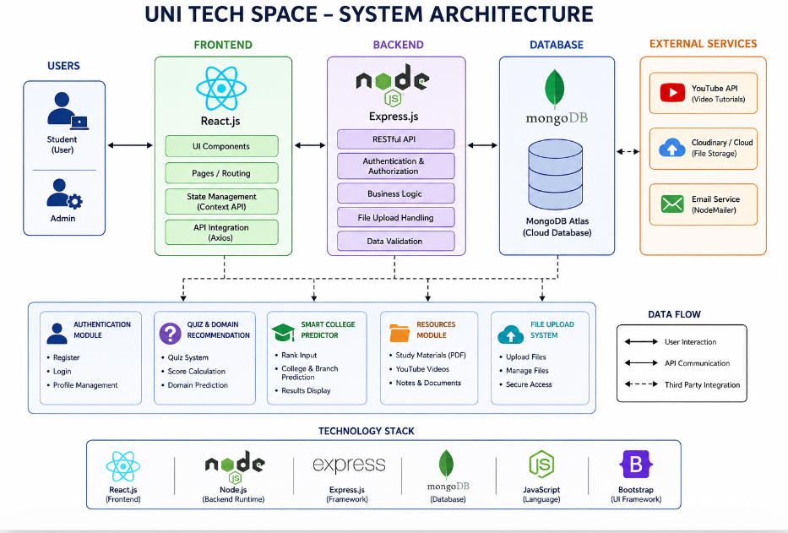

Simple Architecture Flow:

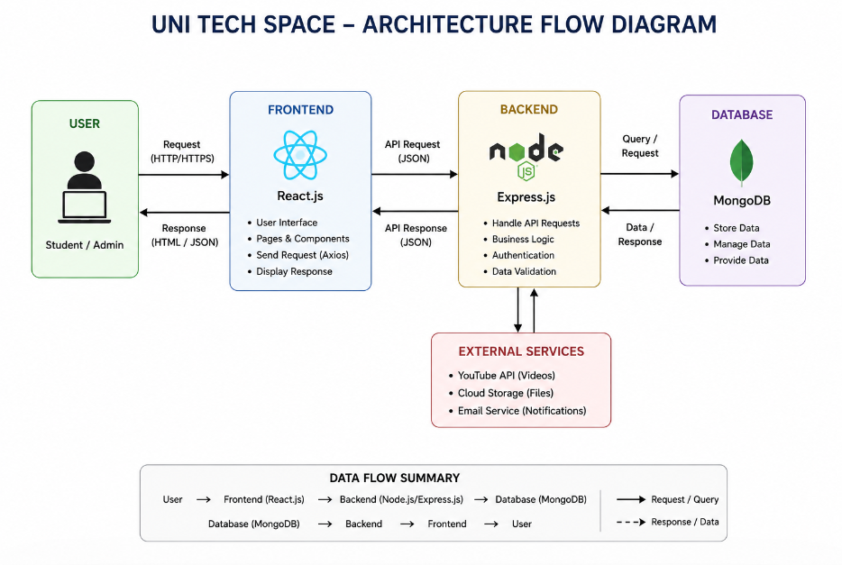
3.2 SYSTEM FLOW
Step-by-step working flow:
- User Login/Register
- Access Dashboard
- Explore Domains
- Attempt Quiz
- Get Recommended Domain
- Use College Predictor
- Access Learning Resources
- Upload Notes/PDFs

Workflow of the System
- Users first register or log in.
- After authentication, users access the homepage.
- Users can explore technical domains.
- Users take a quiz based on interests and skills.
- The system predicts the most suitable domain.
- Users can access the college predictor.
- Learning resources and videos are available.
- Users can upload notes and PDFs.

3.3 MODULE DESCRIPTION
1. Authentication Module
This module handles user registration and login securely.
Features
- User Login
- User Registration
- Session Management

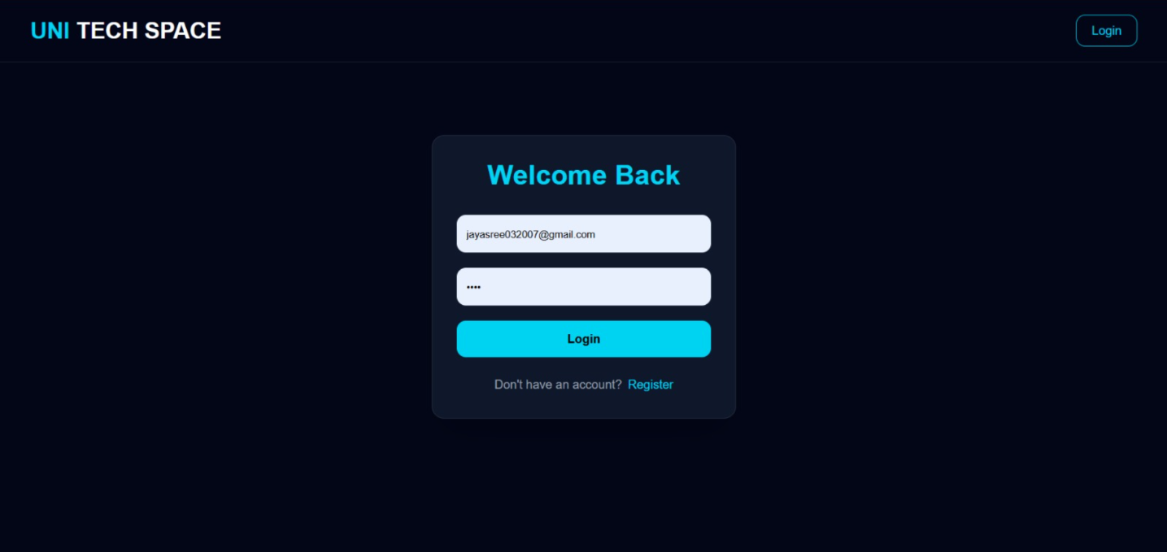

2. Home Module
Displays the main dashboard and navigation options.
Features
- Explore Domains
- Take Quiz
- Access Predictor
- Access Resources

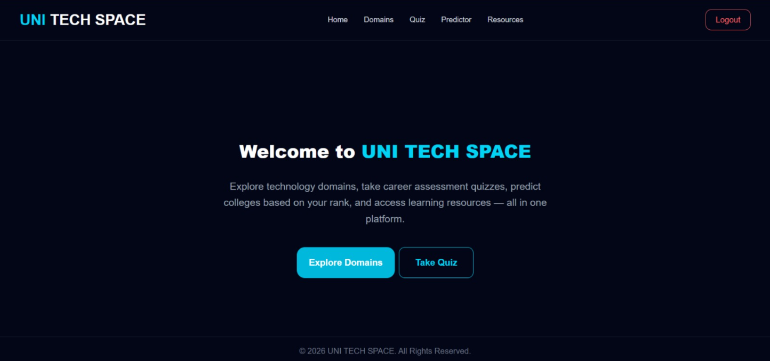

3. Domain Exploration Module
Allows users to explore various technology domains.
Domains Included
- Artificial Intelligence
- Web Development
- Cybersecurity
- Cloud Computing
- Data Science
- App Development

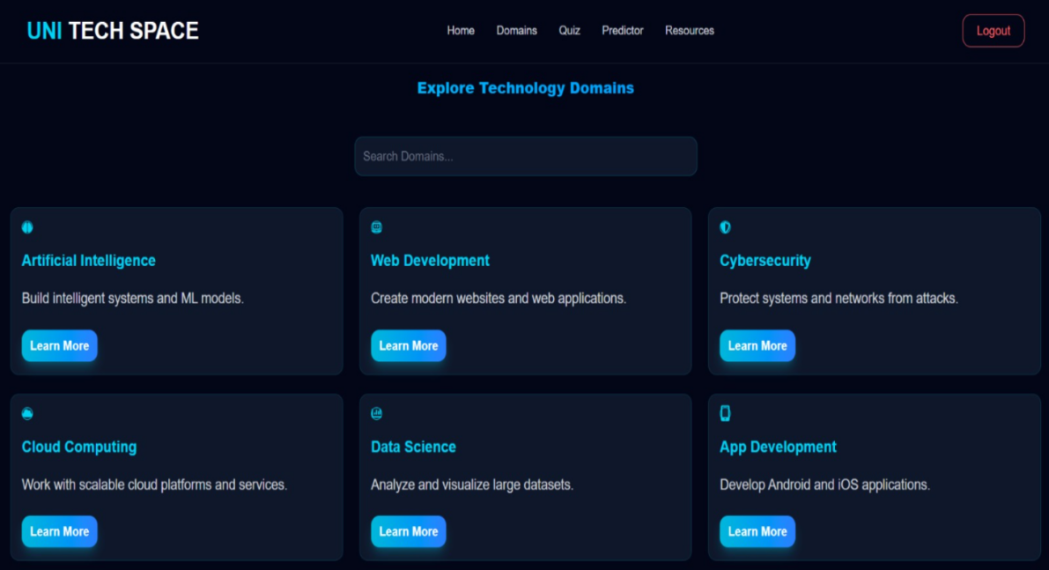

4. Quiz Module
Conducts quizzes to analyze user interests and skills.
Features
- Multiple Choice Questions
- Skill-Based Assessment
- Interactive Interface

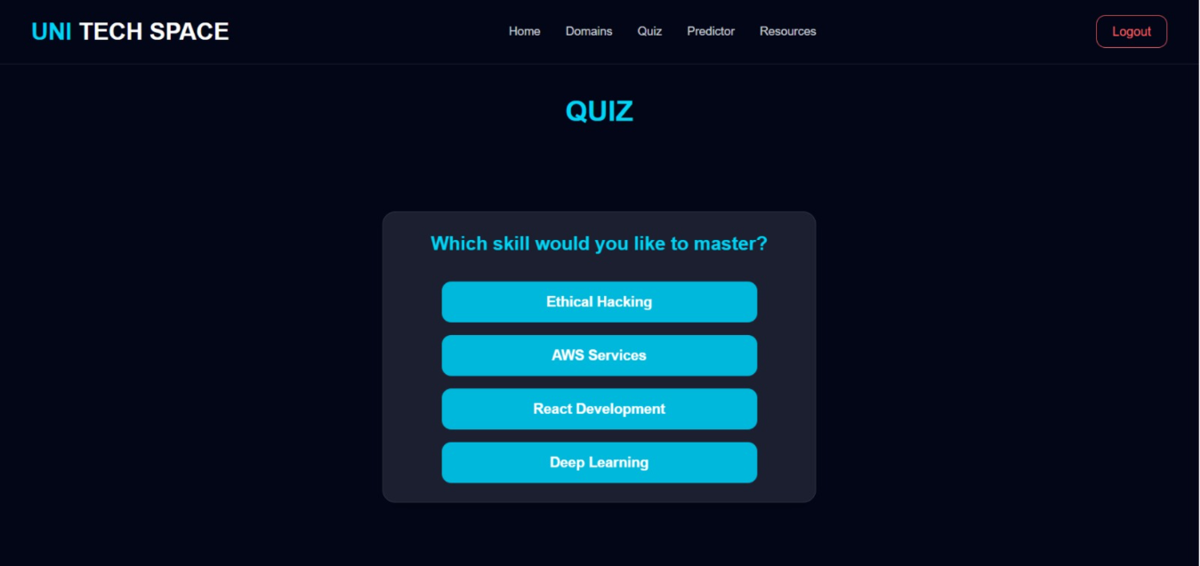

5. Domain Recommendation Module
Predicts suitable technology domains based on quiz responses.
Example Recommendation
- Artificial Intelligence
- Skills Required
- Salary Information
- Learning Roadmap
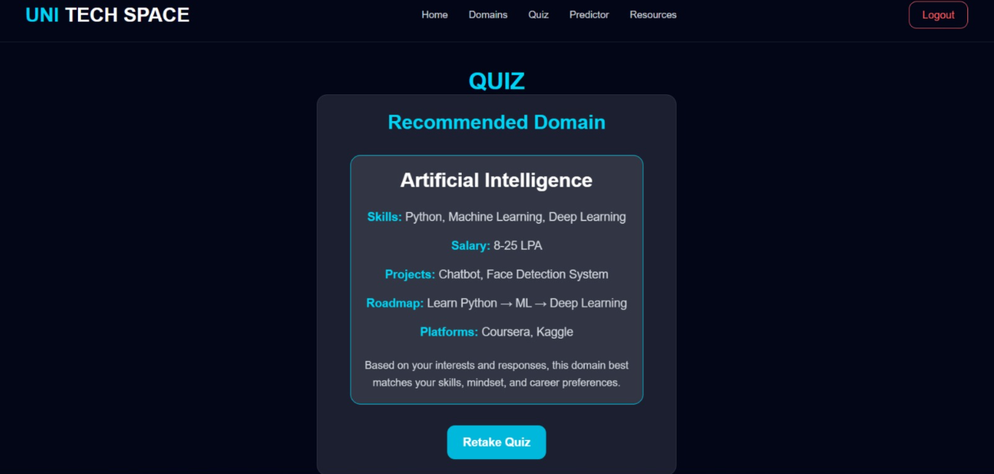

6. Smart College Predictor Module
Predicts suitable colleges based on entered rank.
Features
- Rank-Based College Prediction
- Branch Information
- Placement Details
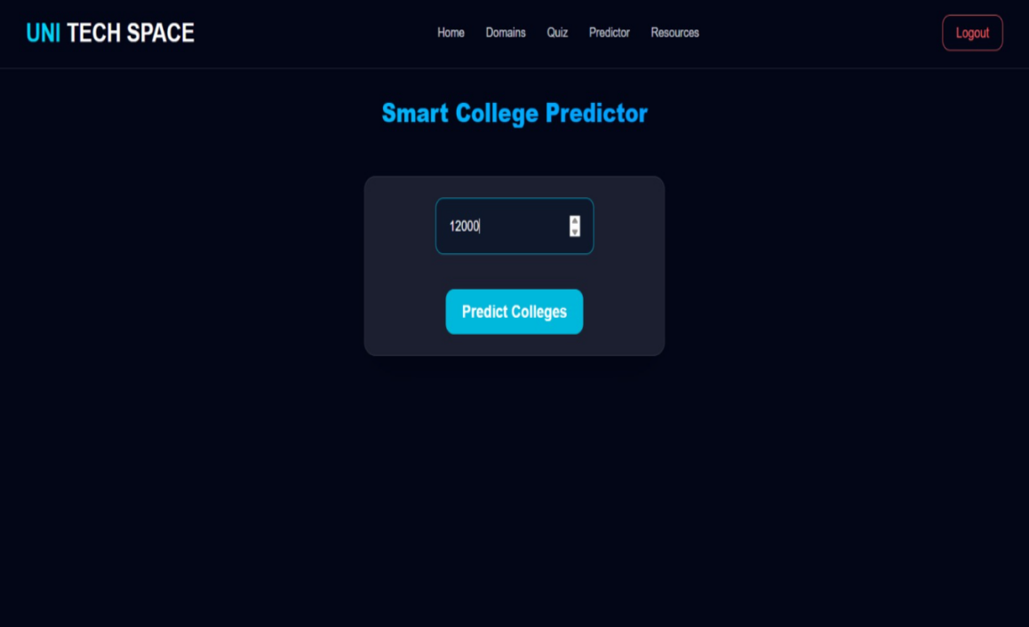

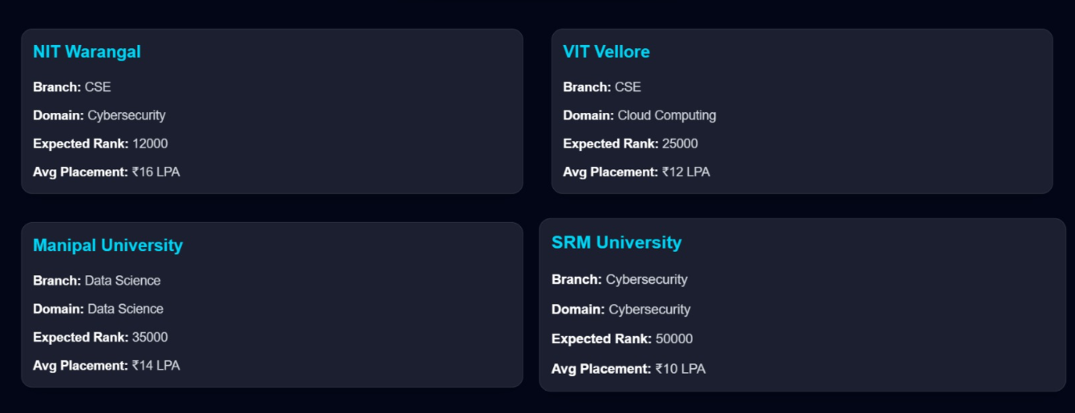

7. Resources Module
Provides educational resources and YouTube learning videos.
Features
- Watch Video Tutorials
- Access Notes and PDFs
- Upload Learning Materials
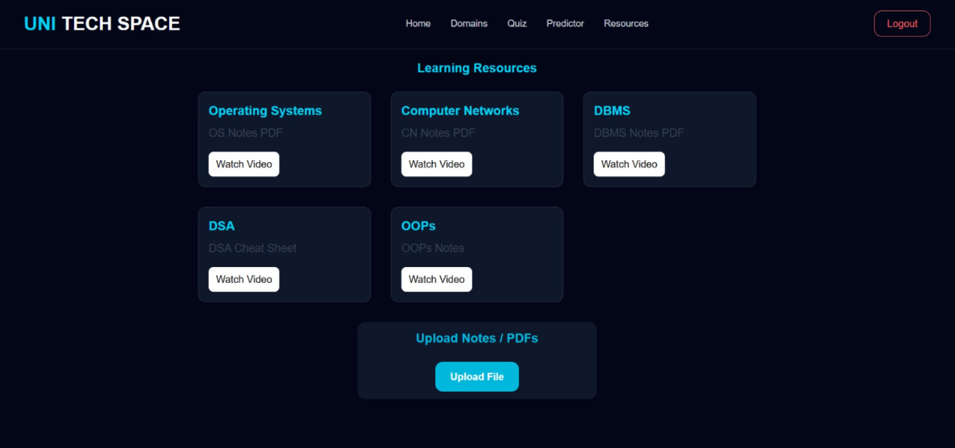

3.4 UML DIAGRAM
1. Use Case Diagram
Actors
- User
- Admin
Functionalities
- Login/Register
- Explore Domains
- Take Quiz
- Predict Domain
- Predict Colleges
- Access Resources
- Upload Files
Simple Structure:
User → Login
User → Access System
Admin → Monitor Activity
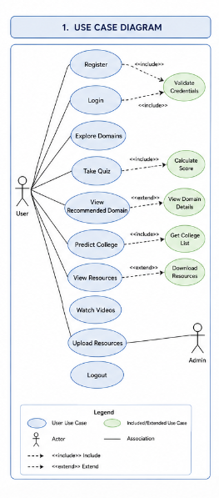
Fig 3.2.1 Use Case Diagram
2. Class Diagram
Main Classes:
- User
- Quiz
- Domain
- CollegePredictor
- Resource

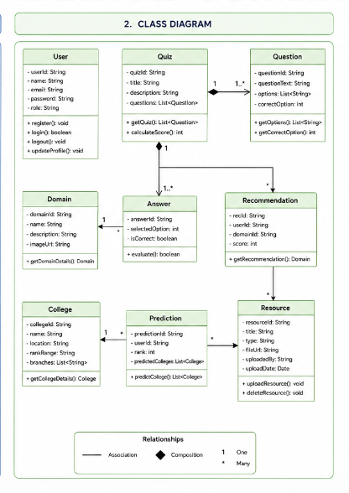
Fig 3.2.2 Class Diagram

3. Sequence Diagram (Login & Access Control)
The sequence diagram shows how the user’s login request is processed and verified by the system.
Flow:
User → Frontend : Login/Register
Frontend → Backend : Send User Credentials
Backend → Database : Verify User Data
Database → Backend : Validation Response
Backend → Frontend : Login Success
Frontend → User : Display Dashboard

User → Frontend : Start Quiz
Frontend → Backend : Submit Quiz Answers
Backend → Database : Process Quiz Data
Database → Backend : Predicted Domain
Backend → Frontend : Send Recommendation
Frontend → User : Display Recommended Domain

User → Frontend : Enter Rank
Frontend → Backend : Send Rank Details
Backend → Database : Fetch College Data
Database → Backend : College Results
Backend → Frontend : Send Prediction
Frontend → User : Display Colleges

User → Frontend : Access Resources
Frontend → Backend : Request Resources
Backend → Database : Fetch Videos/PDFs
Database → Backend : Resource Data
Backend → Frontend : Send Resources
Frontend → User : Display Learning Materials

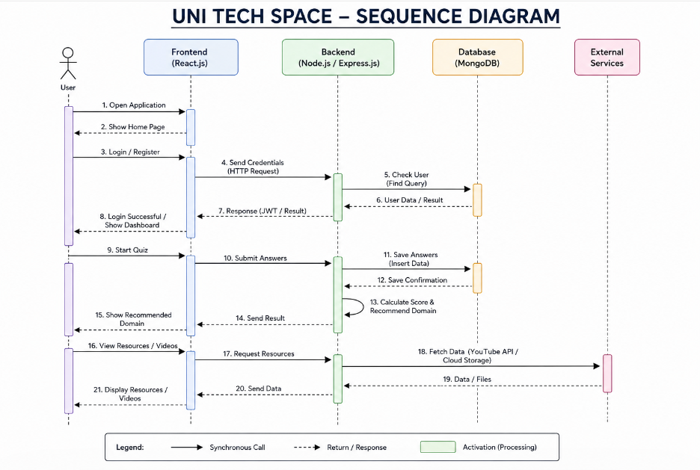
Fig 3.2.3 Sequence Diagram

4. Activity Diagram
- The activity diagram represents the overall workflow of the system.
- The process starts when the user enters login credentials.
- The system verifies the credentials and performs OTP validation.
- If authentication is successful, access is granted based on user role.
- If login fails repeatedly, the system locks the account.
- The system monitors user activity and logs out after inactivity.
- Finally, the process ends after logout.

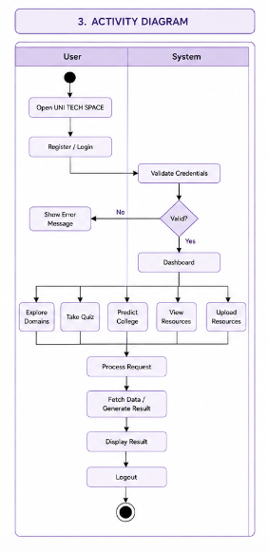
Fig 3.2.4 Activity Diagram

CHAPTER-4
IMPLEMENTATION
4.1 ENVIRONMENT SETUP
4.1.1 Development Environment
Tools Used
- Visual Studio Code
- Node.js
- MongoDB
- React.js
Setup Process
- Install Node.js
- Setup MongoDB Database
- Configure Backend Server
- Run React Frontend
- Connect Database

4.2 IMPLEMENTATION OF MODULES
Authentication Module
Implemented using secure login and registration forms.
Domain Exploration Module
Implemented using responsive cards for each domain.
Quiz Module
Implemented using dynamic question rendering and scoring logic.
Recommendation Module
Implemented using score-based domain prediction.
College Predictor Module
Implemented using rank comparison logic.
Resources Module
Implemented with:
- YouTube video integration
- PDF viewing
- File upload system
Implemented using secure login and registration forms.
Domain Exploration Module
Implemented using responsive cards for each domain.
Quiz Module
Implemented using dynamic question rendering and scoring logic.
Recommendation Module
Implemented using score-based domain prediction.
College Predictor Module
Implemented using rank comparison logic.
Resources Module
Implemented with:
- YouTube video integration
- PDF viewing
- File upload system

4.3 INTEGRATION AND DEVELOPMENT
The integration and development phase of UNI TECH SPACE involved combining all modules into a single functional web application. The frontend developed using React.js was connected with the backend developed using Node.js and Express.js through APIs.
MongoDB was integrated to store user details, quiz responses, resources, uploaded files, and prediction data. The authentication module was connected with all features to provide secure user access.
Modules such as Domain Exploration, Quiz System, Smart College Predictor, and Resources Section were integrated successfully to ensure smooth data flow and user interaction. The application was tested properly to provide a responsive, secure, and user-friendly experience.
CHAPTER-5
EVALUATION
5.1 MODULES
The evaluation phase of UNI TECH SPACE was carried out to verify the performance and functionality of all modules in the system. Various features such as user authentication, domain exploration, quiz-based recommendation, smart college prediction, and resources management were tested using different inputs.
Tested Modules
- Login/Register
- Domain Exploration
- Quiz
- Domain Recommendation
- College Predictor
- Resources Upload
The quiz module was evaluated based on the accuracy of domain recommendations generated from user responses. The Smart College Predictor was tested with different rank values to ensure correct college and branch suggestions. The Resources Module was checked for proper video access, file uploads, and resource availability.

5.2 EVALUATION METRICS
Metrics Used
- Accuracy
- Response Time
- User Experience
- Functional Testing
he performance of UNI TECH SPACE was evaluated using different metrics to ensure proper functionality and user satisfaction.
Accuracy
Accuracy was used to measure how correctly the system predicts suitable technology domains based on quiz responses and how accurately the college predictor suggests colleges according to user ranks.

Response Time
Response time measures how quickly the system processes user requests such as login, quiz submission, domain prediction, and resource loading. The application provides fast responses for better user experience.
User Experience
User experience was evaluated based on the simplicity of navigation, responsiveness of the interface, and ease of accessing features like quizzes, resources, and predictors.
Functional Testing
Functional testing was performed to verify whether all modules such as Login/Register, Domain Exploration, Quiz System, Smart College Predictor, and Resources Module work correctly without errors.
Reliability
Reliability measures the consistency of the system in providing correct outputs and maintaining stable performance during usage.
5.3 TEST CASES
Flow diagram
User Input
↓
Module Request Sent
↓
System Processes Request
↓
Database Verification
↓
Expected Output Generated
↓
Result Displayed to User
↓

Test Result (Pass/Fail)
Login Module
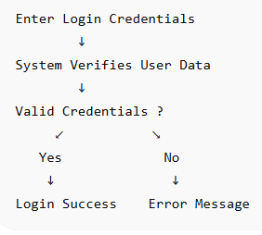
Quiz & Recommendation Module
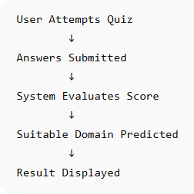
Smart College Predictor
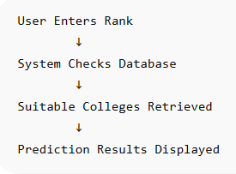
Resources Module
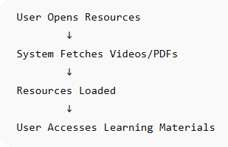

5.4 RESULTS
The project successfully:
- Predicted suitable domains
- Provided technology exploration
- Suggested colleges based on rank
- Allowed resource sharing
- Integrated learning videos
- Improved student guidance experience

CHAPTER 6
CONCLUSION AND FUTURE ENHANCEMENT
CONCLUSION:
UNI TECH SPACE was successfully developed as a web-based platform that provides career guidance, technology domain exploration, and educational resources for students. The project combines multiple functionalities such as quiz-based domain recommendation, smart college prediction, learning resources, YouTube video integration, and file upload features into a single centralized system.
The platform helps students identify suitable technology domains based on their interests and skills through an interactive quiz module. It also assists users in finding suitable colleges and branches using the Smart College Predictor. The Resources Module provides access to study materials, PDFs, notes, and YouTube tutorials, which improves the learning experience of users.
The system was developed using modern web technologies such as React.js, Node.js, Express.js, and MongoDB, which provide a responsive, secure, and user-friendly interface. User authentication ensures secure access to all modules and protects user data.
The project successfully achieved its main objectives by providing:
- Career guidance for students
- Personalized domain recommendations
- College prediction support
- Centralized learning resources
- Secure and interactive user experience
Overall, UNI TECH SPACE serves as an effective educational and career guidance platform that helps students make better decisions regarding their future in technology-related fields.
Key Achievements:
The following are the major achievements of the UNI TECH SPACE project:
- Successfully developed a centralized web platform for career guidance and learning support.
- Implemented secure user authentication using Login and Registration modules.
- Developed a quiz-based recommendation system to predict suitable technology domains.
- Integrated Smart College Predictor to suggest colleges and branches based on user rank.
- Provided educational resources including PDFs, notes, and YouTube video tutorials.
- Implemented file upload functionality for sharing and accessing study materials.
- Created a responsive and user-friendly interface using modern web technologies.
- Successfully integrated frontend, backend, and database components for smooth functionality.
- Improved accessibility to learning resources and career guidance through a single platform.

FUTURE ENHANCEMENTS:
The UNI TECH SPACE project can be further improved by implementing the following enhancements:
- Integration of Artificial Intelligence for more accurate domain recommendations.
- Development of a mobile application for better accessibility on smartphones.
- Addition of chatbot support for instant user assistance and guidance.
- Real-time college counseling and admission data integration.
- Personalized dashboards based on user interests and activity.
- Implementation of advanced analytics and progress tracking features.
- Addition of discussion forums and community interaction features.
- Cloud storage integration for better file management and scalability.
- Multi-language support to improve usability for different users.

REFERENCES
• React.js Official Documentation
https://reactjs.org/
• Node.js Official Documentation
https://nodejs.org/
• Express.js Documentation
https://expressjs.com/
• MongoDB Documentation
https://www.mongodb.com/docs/
• JavaScript Documentation – MDN Web Docs
https://developer.mozilla.org/en-US/docs/Web/JavaScript
• HTML & CSS Documentation – W3Schools
https://www.w3schools.com/
• YouTube API Documentation
https://developers.google.com/youtube
• Research Papers on Career Guidance Systems and Recommendation Systems
• Online Resources and Tutorials for MERN Stack Development
• Visual Studio Code Documentation
https://code.visualstudio.com/docs
• GitHub Documentation
https://docs.github.com/
• MongoDB Atlas Documentation
https://www.mongodb.com/atlas/database
• Node Package Manager (NPM) Documentation
https://www.npmjs.com/
• Research Articles on Educational Recommendation Systems
• Web Development Tutorials and Technical Blogs used during project development

APPENDIX AND SAMPLE CODE
DATA DESCRIPTION
The Appendix section contains additional supporting information related to the development and implementation of the UNI TECH SPACE project. It includes sample code snippets, database schemas, API routes, screenshots, and technical details used during the development process.
The project was developed using the MERN Stack technology which includes MongoDB, Express.js, React.js, and Node.js. Various modules such as Authentication, Quiz-Based Recommendation, Smart College Predictor, Resources Management, and File Upload System were implemented and integrated successfully.
The appendix also contains:
- Sample source code used in different modules
- MongoDB database schema
- API route examples
- Login and authentication implementation
- Quiz recommendation logic
- College prediction logic
- File upload implementation
- Screenshots of project interfaces and outputs
This section provides technical reference material and implementation details for better understanding of the project development process.

SAMPLE CODE
- Login Authentication Code
import { useState } from "react";
import { useNavigate } from "react-router-dom";

import Navbar from "../components/Navbar";

import { toast } from "react-toastify";

function Login() {

const navigate = useNavigate();

const [isRegister, setIsRegister] = useState(false);

const [formData, setFormData] = useState({
name: "",
email: "",
password: "",
});

const handleChange = (e) => {

setFormData({
...formData,
[e.target.name]: e.target.value,
});
};

const handleSubmit = async (e) => {

e.preventDefault();

try {

const url = isRegister
? "http://localhost:5000/api/auth/register"
: "http://localhost:5000/api/auth/login";

const response = await fetch(url, {

method: "POST",

headers: {
"Content-Type": "application/json",
},

body: JSON.stringify(formData),
});

const loginUser = async (req, res) => {
const { email, password } = req.body;

const user = await User.findOne({ email });

if(user && user.password === password){
res.status(200).json({
message: "Login Successful"
});
} else {
res.status(400).json({
message: "Invalid Credentials"
});
}
};

- Quiz Recommendation Logic
function predictDomain(score) {
if(score >= 80){
return "Artificial Intelligence";
}
else if(score >= 60){
return "Web Development";
}
else if(score >= 40){
return "Cyber Security";
}
else{
return "Cloud Computing";
}
}
const domainDetails = {

"Artificial Intelligence": {
skills: "Python, Machine Learning, Deep Learning",
salary: "8-25 LPA",
projects: "Chatbot, Face Detection System",
roadmap: "Learn Python → ML → Deep Learning",
platform: "Coursera, Kaggle",
},

"Web Development": {
skills: "HTML, CSS, React, Node.js",
salary: "5-15 LPA",
projects: "Portfolio Website, E-Commerce App",
roadmap: "Frontend → Backend → Full Stack",
platform: "freeCodeCamp, Udemy",
},

"Cybersecurity": {
skills: "Networking, Linux, Ethical Hacking",
salary: "6-18 LPA",
projects: "Password Analyzer, Packet Sniffer",
roadmap: "Networking → Linux → Security Tools",
platform: "TryHackMe, HackTheBox",
},

"Cloud Computing": {
skills: "AWS, Docker, Kubernetes",
salary: "7-22 LPA",
projects: "Cloud Storage App, CI/CD Pipeline",
roadmap: "Linux → AWS → DevOps",
platform: "AWS Academy, Udemy",
},

};
- Smart College Predictor Code
function predictCollege(rank) {
if(rank <= 5000){
return "NIT Warangal";
}
else if(rank <= 10000){
return "VIT Vellore";
}
else{
return "SRM University";
}
}

- File Upload Code
const multer = require("multer");

const storage = multer.diskStorage({
destination: function(req, file, cb) {
cb(null, "uploads/");
},
filename: function(req, file, cb) {
cb(null, Date.now() + "-" + file.originalname);
}
});

const upload = multer({ storage: storage });

- Sample MongoDB Schema
const userSchema = new mongoose.Schema({
name: String,
email: String,
password: String
});

- Sample API Route
router.post("/login", loginUser);
router.post("/quiz", submitQuiz);
router.post("/predict", predictCollege);

7. Technologies Used
- React.js
- Node.js
- Express.js
- MongoDB
- JavaScript
- HTML & CSS

8.Screenshots Included in Appendix
- Login Page
- Home Dashboard
- Quiz Module
- Recommended Domain Result
- Smart College Predictor
- Resources Module
- File Upload Section

